SPRINT 4

SMART FARMER-IoT BASED SMART FARMING APPILCATION

**TEAM ID:**PNT2022TMID52627

Creating a MIT Account

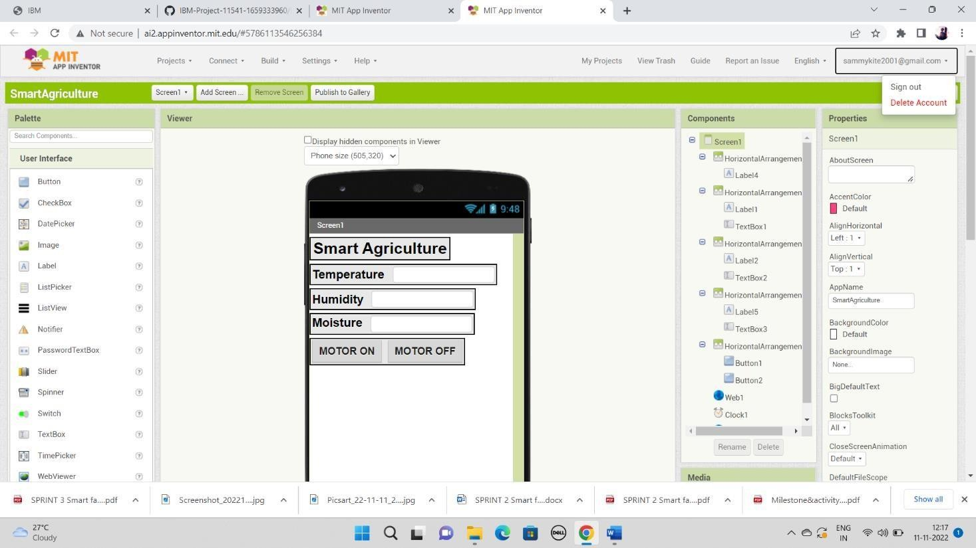

Creating Blocks to Build the Mobile Application

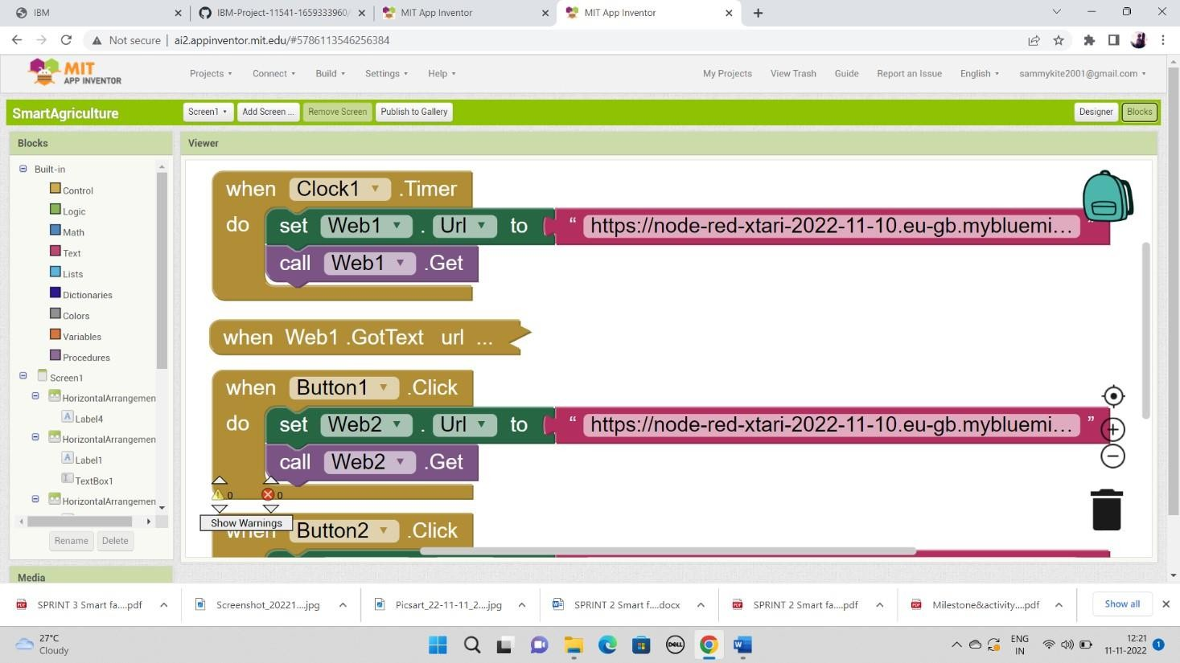

Configuring the Blocks with the Node Red Link

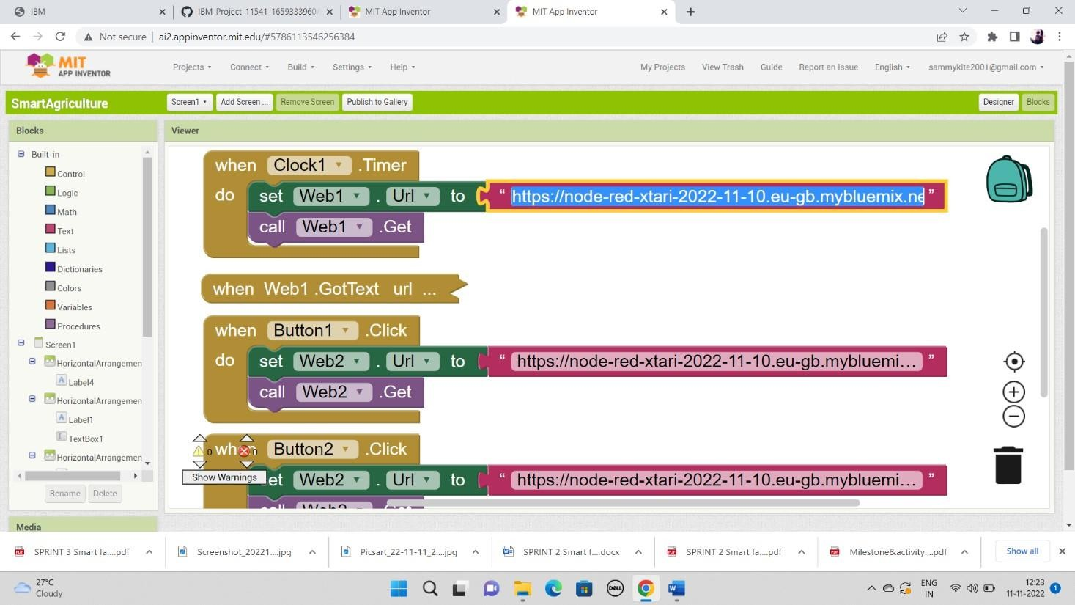

Creating the Mobile Interface

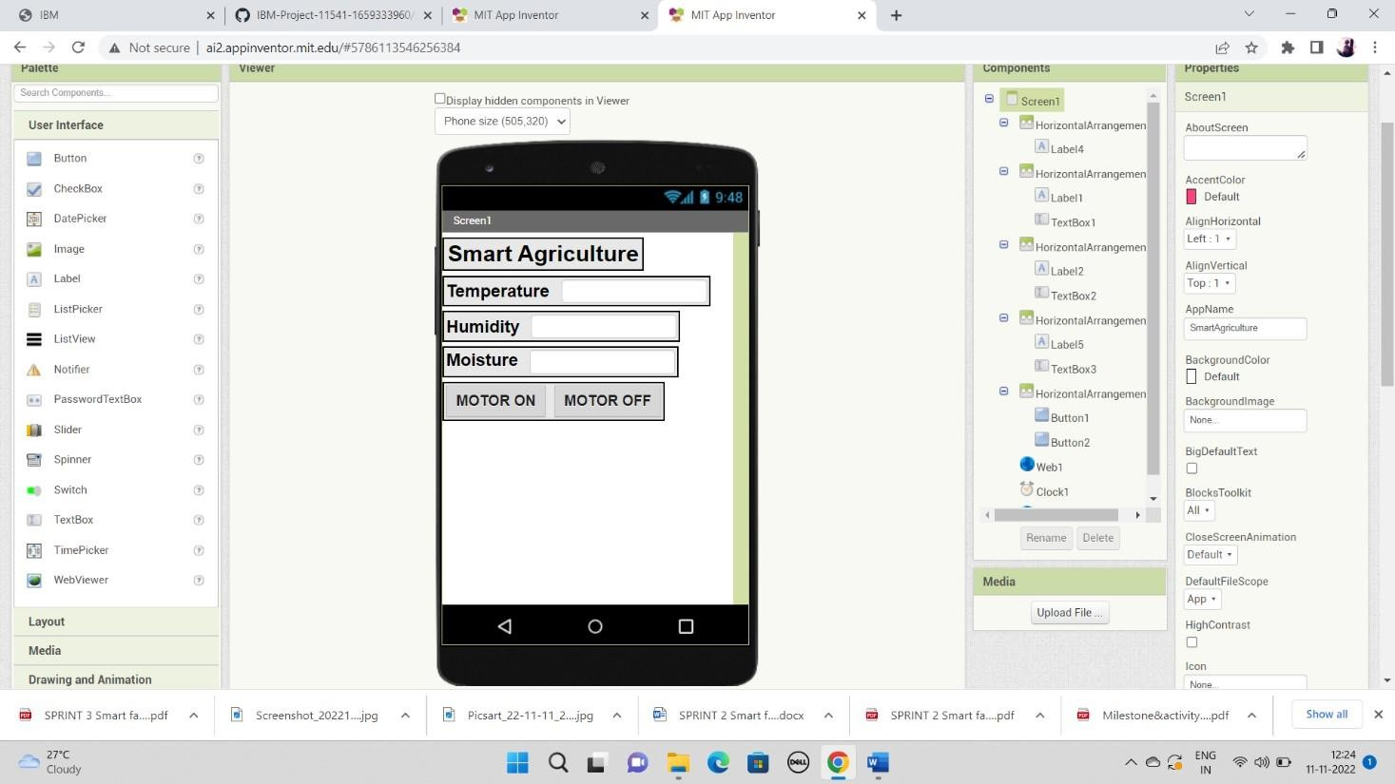

Connecting it to the AI Companion

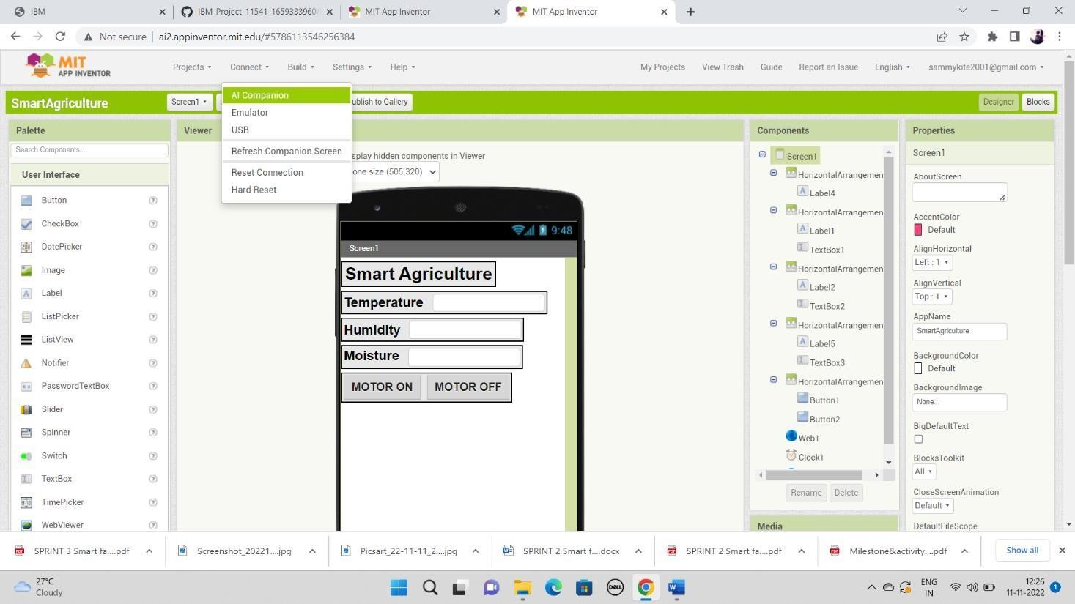

QR Code to Connect with the Mobile

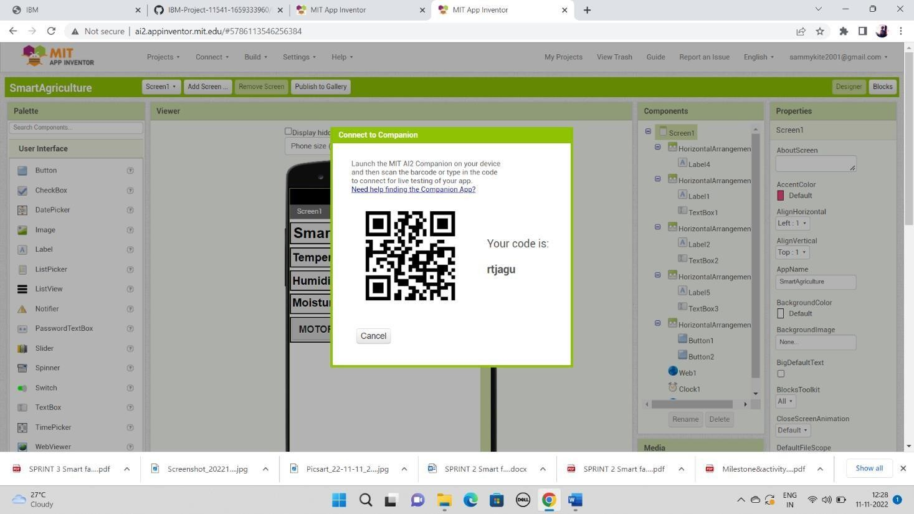

Mobile Connected Interface

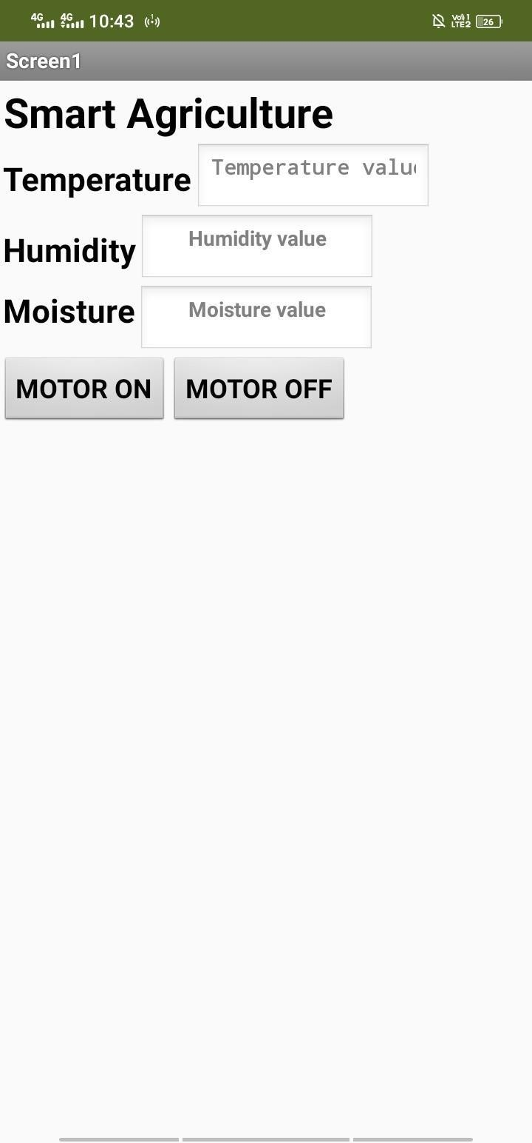

Receiving Data

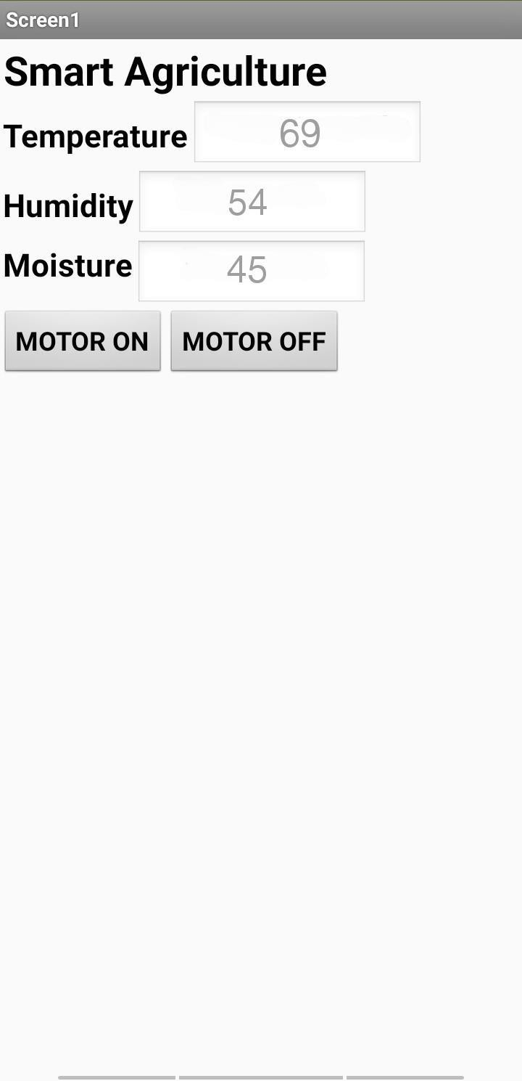

Motor ON and Motor OFF Command and Output

